Supplementary Information for

Graph Masked Autoencoder with Multi-Head Latent Attention Mechanism for Gene Regulatory Link Prediction

Zhiwei Cao, Xupeng Wang, Wenhao Li, Yichao Zhang, Yuliang Pan, Jihong Guan,
and Shuigeng Zhou

Supplementary Note 1: Computational validation of NUPR1 regulatory interactions
To further investigate the regulatory role of NUPR1 within the metastatic glycolytic network predicted by our model, we performed an in silico knockout simulation using scTenifoldKnk on a public single-cell RNA-seq dataset of basal-like breast cancer. This perturbation identified a set of differentially expressed genes sensitive to NUPR1 knockdown. Comparing these perturbation-sensitive genes with NUPR1's predicted transcriptional targets revealed a significant overlap: three genes—CKB, BNIP3, and RPL31—were identified by both approaches (Supplementary Fig. S1). These genes have been independently implicated in glycolysis and breast cancer progression [1-3], lending biological plausibility to their predicted regulation by NUPR1.
We then performed KEGG pathway enrichment analysis on all NUPR1-predicted target genes. The results showed significant enrichment in pathways critical for cancer progression and metabolism (Supplementary Fig. S2), including Breast cancer, PI3K-Akt signaling pathway, ErbB signaling pathway, mTOR signaling pathway, and HIF-1 signaling pathway. Notably, the overlapping genes from the perturbation analysis (CKB, BNIP3, and RPL31) are established components of these pathways. This convergence of in silico perturbation evidence, model predictions, and established pathway knowledge functionally positions NUPR1 as an upstream regulator of a transcriptional program that promotes metabolic reprogramming and invasive potential in breast cancer metastasis.
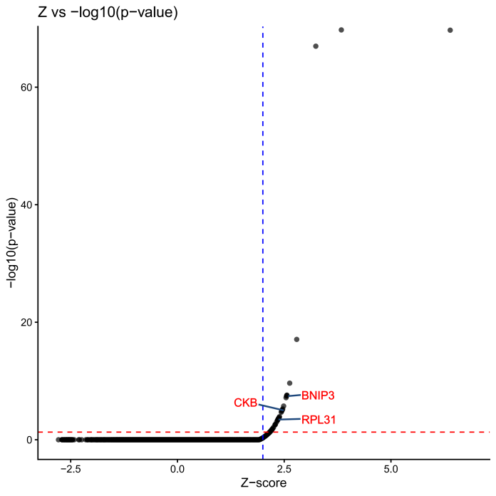
Figure S1. Overlap between NUPR1-predicted target genes and NUPR1-knockdown-sensitive genes. The figure displays genes whose expression was significantly altered following NUPR1 knockdown via scTenifoldKnk (p < 0.05 and |Z| > 2). Among these, genes overlapping with the predicted targets of NUPR1 from our model are highlighted in red.
Figure S2. KEGG pathway enrichment analysis of NUPR1-predicted target genes. Bubble plot showing significantly enriched pathways (p < 0.05) among genes predicted to be regulated by NUPR1 in the metastasis-specific GRN. GeneRatio represents the proportion of target genes mapping to each pathway. Dot size indicates the number of genes per pathway, and color intensity represents -log10(p-value). Key enriched pathways related to breast cancer progression and metabolic reprogramming are labeled.

References
[1] Q. Yu, W. Fu, Y. Fu et al., "BNIP3 as a potential biomarker for the identification of prognosis and diagnosis in solid tumours," Molecular Cancer, vol. 22, no. 1, p. 143, 2023.
[2] J. Xu, S. Qin, Y. Yi et al., "Delving into the heterogeneity of different breast cancer subtypes and the prognostic models utilizing scRNA-seq and bulk RNA-seq," International Journal of Molecular Sciences, vol. 23, no. 17, p. 9936, 2022.
[3] R. I. Krutilina, H. Playa, D. L. Brooks et al., "HIF-dependent CKB expression promotes breast cancer metastasis, whereas cyclocreatine therapy impairs cellular invasion and improves chemotherapy efficacy," Cancers, vol. 14, no. 1, p. 27, 2021.

Supplementary Note 2: Ablation studies of GMAMLink components
To systematically quantify the individual contributions of the GraphMAE and MLA components, we conducted comprehensive ablation experiments across all seven cell types. For each configuration, we created two ablation variants: (1) w/o GraphMAE, where the pre-trained GraphMAE embeddings were replaced with raw gene expression as node features, and (2) w/o MLA, where the multi-head latent attention mechanism was replaced with naive feature concatenation. All other model components and training procedures were kept identical to the full GMAMLink. Performance was evaluated using AUC averaged across the four benchmark networks (STRING, non-specific ChIP-seq, cell-type-specific ChIP-seq, and LOF/GOF) for both TFs+500 and TFs+1000 settings.
Figure S3 presents the complete ablation results across all cell types. The key findings are summarized below:
- GraphMAE contribution. Removing GraphMAE led to consistent performance degradation across all seven cell types under the TFs+500 setting, with AUC drops ranging from 0.01 to 0.07. Under the TFs+1000 setting, six out of seven cell types also exhibited declines between 0.02 and 0.06, with the sole exception of mHSC-L, where AUC remained nearly unchanged (from 0.86 to 0.85). The most substantial drops were observed in mESC (0.87 → 0.80 under TFs+500; 0.87 → 0.81 under TFs+1000) and mDC (0.89 → 0.83 under TFs+1000), highlighting the critical role of GraphMAE in capturing biologically meaningful features. These results confirm that GraphMAE consistently outperforms raw expression data across diverse cellular contexts.
- MLA contribution. The removal of MLA led to even more pronounced performance degradation in certain cell types, most notably in mHSC-L, where average AUC dropped from 0.87 to 0.72 under TFs+500 (a relative decrease of 17.2%) and from 0.85 to 0.73 under TFs+1000. Consistent performance declines were also observed across other cell types upon MLA removal, with AUC decreases ranging from 0.03 to 0.07 under TFs+500 and from 0.03 to 0.08 under TFs+1000. These results highlight the critical role of MLA in capturing complex regulatory interactions by adaptively fusing structural and semantic features, and confirm its consistent advantage over naive feature concatenation across diverse cellular contexts.
Synergistic effects. Importantly, no ablation variant consistently outperformed the full GMAMLink model across the majority of datasets and settings. The synergy between GraphMAE and MLA is especially evident in cell types where removing either component led to performance dropping below that of baseline methods. These findings confirm that GraphMAE and MLA fulfill complementary roles: GraphMAE enhances feature robustness against noise, while MLA effectively integrates these representations with topological context for accurate link prediction.
Figure S3. Ablation studies quantifying component contributions. Performance comparison of full GMAMLink against variants lacking GraphMAE or MLA across multiple cell types under (A) TFs+500 and (B) TFs+1000 settings. Values represent mean AUC averaged across four benchmark networks. The full model consistently outperforms ablation variants, with the most pronounced gaps observed in mESC (GraphMAE ablation) and mHSC-L (MLA ablation).

Supplementary Note 3: Functional enrichment and hub gene analysis of metastasis-specific GRNs
Table S1. The enriched outcome of the GRN of metastasis and primary tumor.
Pathway | $P_{p}$ adj | $P_{m}$ adj
Breast cancer | 5.88E-64 | 4.91E-64
Pathway in cancer | 1.61E-30 | 7.00E-30
Cell cycle | 5.30E-10 | 5.19E-10
Cell differentiation (GO:0030154) | 2.45E-10 | 1.83E-10
Regulation of cell differentiation (GO:0045595) | 1.55E-08 | 1.31E-08
Positive regulation of macromolecule biosynthetic process (GO:0010557) | 5.71E-31 | 9.51E-31
Positive regulation of DNA biosynthetic process (GO:2000573) | 4.51E-11 | 4.01E-10
Positive regulation of cellular biosynthetic process (GO:0031328) | 6.76E-15 | 1.23E-14
Table S2. Top10 go enrichment results metastatic and primary tumor specific GRNs.
Metastasis
Pathway | $P_{m}$ adj
Extracellular exosome | 1.24E-12
Extracellular vesicle | 1.94E-12
Extracellular organelle | 2.01E-12
Extracellular space | 2.40E-09
Response to chemical | 1.49E-08
Cellular nitrogen compound biosynthetic process | 4.86E-08
Extracellular region part | 7.14E-08
Protein-containing complex | 9.41E-08
Translation | 1.29E-07
Vesicle | 1.33E-07
Primary
Pathway | $P_{p}$ adj
Nucleoplasm | 1.52E-10
Nuclear lumen | 1.21E-07
Nuclear part | 1.23E-07
Cytosolic small ribosomal subunit | 1.93E-07
Protein-containing complex | 4.85E-07
Establishment of protein localization to organelle | 1.20E-06
Cytosolic part | 1.22E-06
Viral transcription | 2.49E-06
Cellular macromolecule biosynthetic process | 2.76E-06
Viral process | 4.23E-06
Table S3. TERMS related to glycolysis
Pathway | $P_{m}$ adj
HIF-1 signaling pathway | 3.5E-04
ErbB signaling pathway | 2.8E-02
Canonical glycolysis (GO:0061621) | 6.2E-03
Glycolytic process (GO:0006096) | 7.2E-03
Glycolytic process through fructose-6-phosphate (GO:0061615) | 7.5E-03
Glycolytic process through glucose-6-phosphate (GO:0061620) | 7.5E-03
Glucose catabolic process to pyruvate (GO:0061718) | 6.2E-03
Glucose metabolic process (GO:0006006) | 1.3E-02
Glucose catabolic process (GO:0006007) | 1.0E-03
Table S4. TOP10 MCC score rank
Rank | Gene | Score
1 | NUPR1 | 9
2 | PKM | 8
2 | GAPDH | 8
4 | PGM1 | 7
5 | ALDOA | 6
5 | TP53 | 6
5 | PGK1 | 6
8 | RB1 | 3
9 | FOS | 2
9 | BBC3 | 2

